**SMART PUBLIC RESTROOM : FORECASTING AND PREDICTIVE MODELING**

**Introduction:**

In our country, people do not have enough knowledge of using toilets. This leads to several diseases, such as Malaria, Hepatitis, Flu, Cholera, Streptococcus, Typhoid, etc. Hence we introduce the concept in the IOT called "Swachh Shithouse" The term Swachh means ‘Clean’. Then the term Shithouse means ‘Toilet’. It is introduce to use and maintain the toilets in the clean and hygienic way. The project is based on IOT concepts using different sensors like smell sensor, dirt sensor, sonic sensor, RFID reader, Database. Using these materials we are trying to provide the clean toilets and create the awareness among the people.

In most Indian villages and slums, public sanitation remains woefully inadequate, with rampant public urination and open defecation due to public toilets being dirty, too few, or poorly maintained. The authorities expend a huge amount of money and manpower to maintain these public toilets. Nevertheless, all these efforts go in vain as there does not exist a centralized system to monitor the cleanliness of the public toilets, track the quality of cleaning by cleaners. In accordance with this, a system that provides centralized monitoring of all the toilets and provides an interface to the cleaner will be helpful in solving this problem. This paper aims to present an intuitive toilet monitoring system that leverages IoT and Machine Learning. The system incorporates use of various IoT devices, a web server, and a mobile application for the cleaner. The system provides the toilet cleaner and admin with the ability to monitor various cleanliness parameters as well as visualize the future state of the toilet based on past data.

Public area toilets like those in airports, schools, offices, colleges, construction sites and other commercial buildings accumulate countless amounts of bacteria which is a huge concern to the safety of the public. The toilets in public areas may appear clean to the naked eye, but they are teeming with bacteria which can cause health issues. It is made sure that the toilet remains clean while ensuring that the management understands its duties. There are two main sensors being used, a smell sensor and a turbidity sensor which detect any foul smells and the clarity of the water. These sensors are connected to a NodeMCU microcontroller which monitors the changes and feeds them to a database which can be accessed by the management through a mobile application. This is done using a wi-fi module. In this way, the monitoring of toilets is made more efficient and access to the data collected is fingertips away.

**Related Works:**

* In this paper, the plan is to clean not only toilets, but also sewers and healthcare facilities in the city of Pune. It is a major step promoting sanitation and cleanliness. This is a major step towards the ―Swachh Bharat‖ scheme as it promotes the importance of cleanliness in toilets as well as other major industries such as healthcare.
* In this paper, sensors are used to detect smell, water level in thetank and presence of a body which trigger a fan, a water motor and an automatic flusher providing a comfortable experience to the user of the toilet. This project provides comfort as well as good hygiene promotion.
* In this paper, RFID, IR sensor, Gas sensor and sonic sensor detect any presence of dirt or any foul smell in the toilet and send an alert to the management through a buzzer and an LCD display. This project promotes the importance of cleanliness.
* In this paper, IR sensor and gas sensor are used to determine dirt particles in the toilet and sends a message to the organization to clean through GSM module. It also includes an RFID scanner where the user can check how well the toilet has been cleaned with before and after images of the toilet. It promotes the awareness of cleanliness and why it is very important in today‘s daily life.
* In this paper, the main goal is to promote numerous efficiency techniques and technologies like water saving toilet, bi-sloped conveyor belt toilet for separation and recycling purposes and emergency enabled waterless portable private toilet kit to aim at reducing water consumption and separating urine and feces to use waste as fertilizer. This project discusses innovative technologies which can be used in the future.
* In this paper, sensors to detect the state of the toilet and a robotic arm brush is used to clean the toilet automatically without the intervention of humans. This system is focused mainly on improving the environment of toilets in railway systems so that the user can have a good experience during his/her journey.

**Key Components:**

* Smart Sensor Technology: IoT sensors are installed within restroom facilitates monitoring occupancy, toilet cleanliness and supply levels in Realtime.
* Mobile Applications: a user-friendly mobile app provides Realtime restroom availability information and allows users to request cleaning or supplies.
* Cleaning and Maintenance: an administrative portal help facility managers optimize cleaning schedules and supply restocking based on sensor data.
* Sustainability measures: the system incorporates water saving features such as smart flushing and energy.

**System Architecture:**

**A. PROPOSED SYSTEM**

The proposed system consists of two main portions: The first portion includes all the hardware components which pick up all of the data which is detected. The hardware includes the smell sensor, turbidity sensor, microcontroller, Wi-Fi module and the connecting wires. The second portion includes the details about how the data which is picked up is delivered to the organization. This portion includes the database software used to store the data of the foul smell which is detected by the smell sensor and the data of the turbid water picked up by the turbidity sensor. Here, the microcontroller sends a signal to the organization through the Wi-Fi module. The user can access and get details about the notification through a mobile application which has been created for managing the toilet.

**B.BLOCK DIAGRAM**

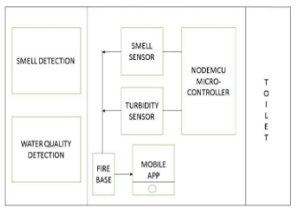

***Fig 1.*** *Block Diagram of Proposed System*

## **C. WORKING MODEL**

The smell sensor is used to detect any unwanted gases present in the toilet. If any foul smell goes into the sensor, it creates a signal. The turbidity sensor tests the transparency of the water to measure its quality and check whether any bacteria is present in the tank. If bacteria are detected, it creates a signal. All the signals are passed through the NodeMCU microcontroller where the constraints of foul smell and turbid water are checked. All of the data is stored inside firebase, which stores all the information about the results. It is an application development software. The data is accessed through a mobile application where the management receives the output message which informs that the toilet must be cleaned. The organization must install this application to access the alerts and view the data which has been received. Then a sweeper is sent to clean the toilet.

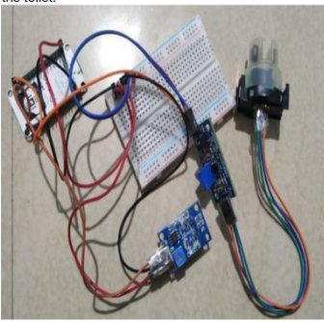

***Fig 2.*** *Working Model*

**D. SEQUENCE DIAGRAM**

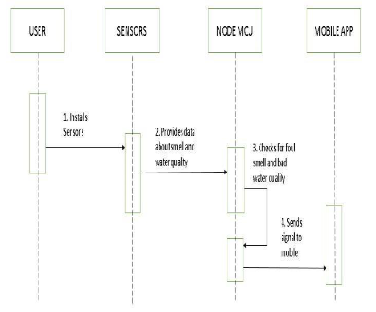

***Fig 3.*** *Sequence Diagram of Proposed System*

# **Details of the modules:**

## **A. TURBIDITY SENSOR**

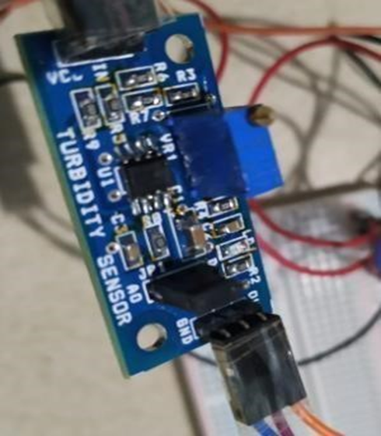

***Fig 4****. Turbidity Sensor Amplifier*

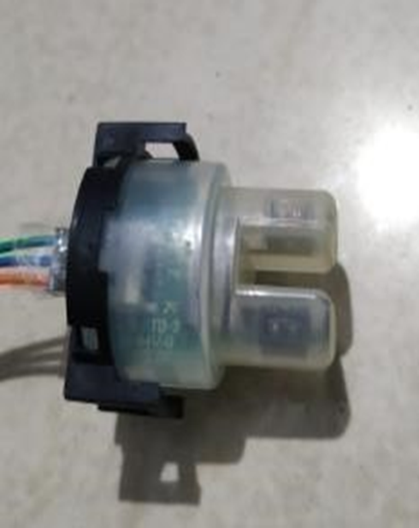

***Fig 5.*** *Turbidity Sensor Probe*

A turbidity sensor is a sensor which is mainly used to measure scattered light suspended by solids in water. As the number of total suspended solids in the water source is increased, the turbidity level of water is increased accordingly. Turbidity sensors can be used in the determination of water quality of small as well as large water bodies.

**B. MQ3 GAS SENSOR**

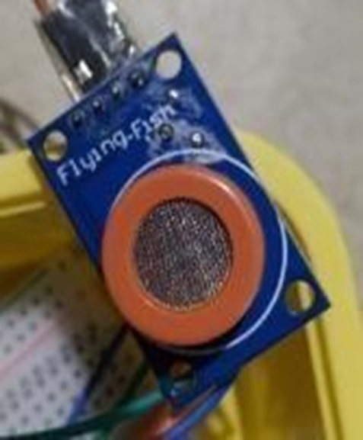

***Fig 6.*** *MQ3 Gas Sensor*

MQ3 gas sensor is an alcohol gas sensor which can detect the presence of gases which contain alcohol traces in them. It is made out of tin in the form of stannic oxide. It can detect alcohol, ethanol and smoke.

**C. NODEMCU WI-FI MODULE**

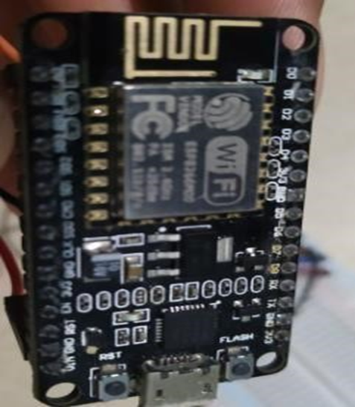

***Fig 7.*** *WI-FI Module ESP8266*

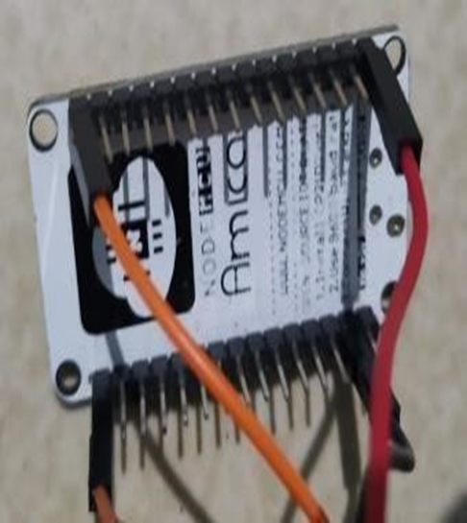

***Figure 8.*** *NodeMCU*

NodeMCU is a development kit that aids in making an IoT project. This module runs on ESP8266 Wi-Fi system on a chip. It is a microcontroller unit which includes a built in WiFi module.

**Implementation:**

This section contains the implementation of the proposed model. Once the sensor is installed and a user has used the toilet, the gas sensor and turbidity check for the constraints. The turbidity sensor reads a lower current if the water is turbid. This sends a signal to NodeMCU which loads the values onto the database. Similarly, the gas sensor detects the foul smell and sends a signal to NodeMCU which again loads the data onto the database. Through the mobile application, the user will receive alerts that the toilet needs to be cleaned. Then, a maintenance staff can be used to physically clean the toilet.

# **Result and Discussion:**

The proposed system provides a good experience for people when using public toilets. Using the technology of internet of things, it helps maintain proper sanitation of the toilets and prevents the spread of contagious diseases. Sanitation starts at the restroom where proper hygiene can be maintained, so it is essential that necessary steps are to be taken to improve the environment of the area. The result is to implement proper maintenance of toilets in order to reduce water wastage and prevent disease spread all while providing a smooth restroom experience. Future works involve a number of features which can be used to enhance the experience of using a restroom. Automatic toilet cleaners which completely clean the toilets without the intervention of humans improve the efficiency and reduce the labor used to clean a toilet. This implements Machine Learning and AI algorithms to create a project which automatically cleans the toilet. Large scale platforms can be created where several toilets can be linked together to improve efficiency in management of toilets. A large database can be used to store and analyze the data to improve the cleaning mechanisms.

**Conclusion:**

The proposed system will create awareness among the public about the necessity of proper sanitation in public restrooms. With this system, the probability of diseases which can spread in public restrooms are also decreased due to proper maintenance. It is a major step closer to proving that cleanliness is in fact, closer to godliness.